FOR IMMEDIATE RELEASE

FACE TO FACE
September 10th - October 24th, 2015

Ethan Cohen New York is delighted to announce FACE TO FACE, a group exhibition that presents a visual dialogue of the portrait genre. An opening reception will take place on Thursday, September 10, from 6-8pm.

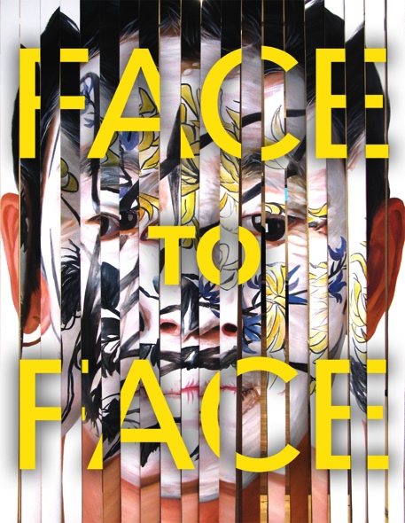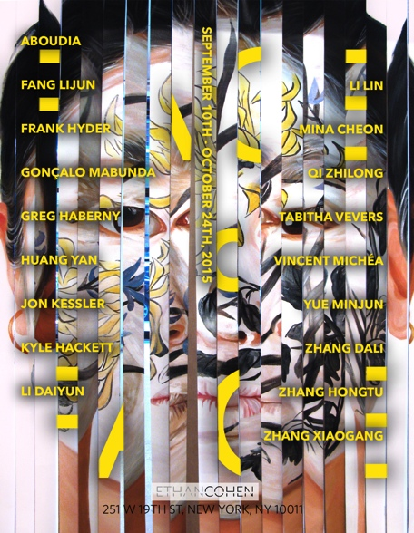

The portrait genre, perhaps the most universal form of expression in art, serves as a highly revealing window onto cultures, how they see themselves, how they see others, and how others see them. As the battlefronts of multiculturalism challenge our frontiers, both internal and external, the face and its depiction offers us a divergent language of perception that we can all share. In “Face To Face” Ethan Cohen gallery explores the genre, drawing on African, Chinese and Western contemporary art to illustrate cultural commonalities and polarities. Through African masks, through portraits by renowned Western and Asian contemporary artists, the show compares disparate ways of seeing both across and within art historical legacies. The face that looks out at us, the way we interpret that look and the way we look back all goes to the heart of how a culture sees the world.

Like the sonnet, the portrait is a unitary form with traditions and conventions so palpable as to make deviations instantly understood, and even interpreted as being intellectual statements. Hence the genre and its permutations often serve as comments on the internal changes in a single esthetic tradition. In early Western modernism, the introduction of African masks to the mental iconography of artists such as Picasso and Brâncuși changed both their perceptual process and the history of Western art itself. But African masks are hardly a monolithic genre and the examples in the show illustrate the diversity within their broad tradition up to the present day when their influence can be felt in the fantastical canvases of Aboudia and the deconstructed weapons sculptures of Mabunda. Out of the usually comfortable topography of a face the artists craft a nightmare laughter of the kind they inherit from masks and witness on the streets. In contrast, we see in the powerful self-portrait by Yuan Yunsheng, the finest standards of the western academic tradition absorbed cross-culturally and expressed by a renowned Chinese Artist.

As a genre commenting on itself portraiture furnishes us with the most sensitive language for what’s happening in the world through permutations in its traditions. Hence Yue Minjun’s world famous laughing-grimacing figures ask contemporary Chinese to question their notions and pretensions of happiness. Greg Haberny, fresh from his triumph at Banksy’s Dismaland, is represented by his deconstructions of pop art icons made of discarded consumer artefacts. Zhang Hongtu’s renowned missing Mao profile-panels scrutinize mass leader-worship images. Mina Cheon treads comparable terrain in her brightly painted parodies of North Korean propaganda posters. Jon Kessler's multimedia solo-show at MOMA PS1 ten years ago and the portraits here illustrate how deconstruction of the materials penetrate the representational image like time and decay. These and other works in the show bring the viewer face to face with identity and its changing content across cultures and across time.

Featuring artworks by Aboudia, Fang Lijun, Frank Hyder, Gonçalo Mabunda, Greg Haberny, Huang Yan, Isaac Aden, Jon Kessler, Kyle Hackett, Li Daiyun, Li Lin, Mina Cheon, Qi Zhilong, Tabitha Vevers, Vincent Michéa, Yuan Yunsheng, Yue Minjun, Zhang Dali, Zhang Hongtu, Zhang Xiaogang.

