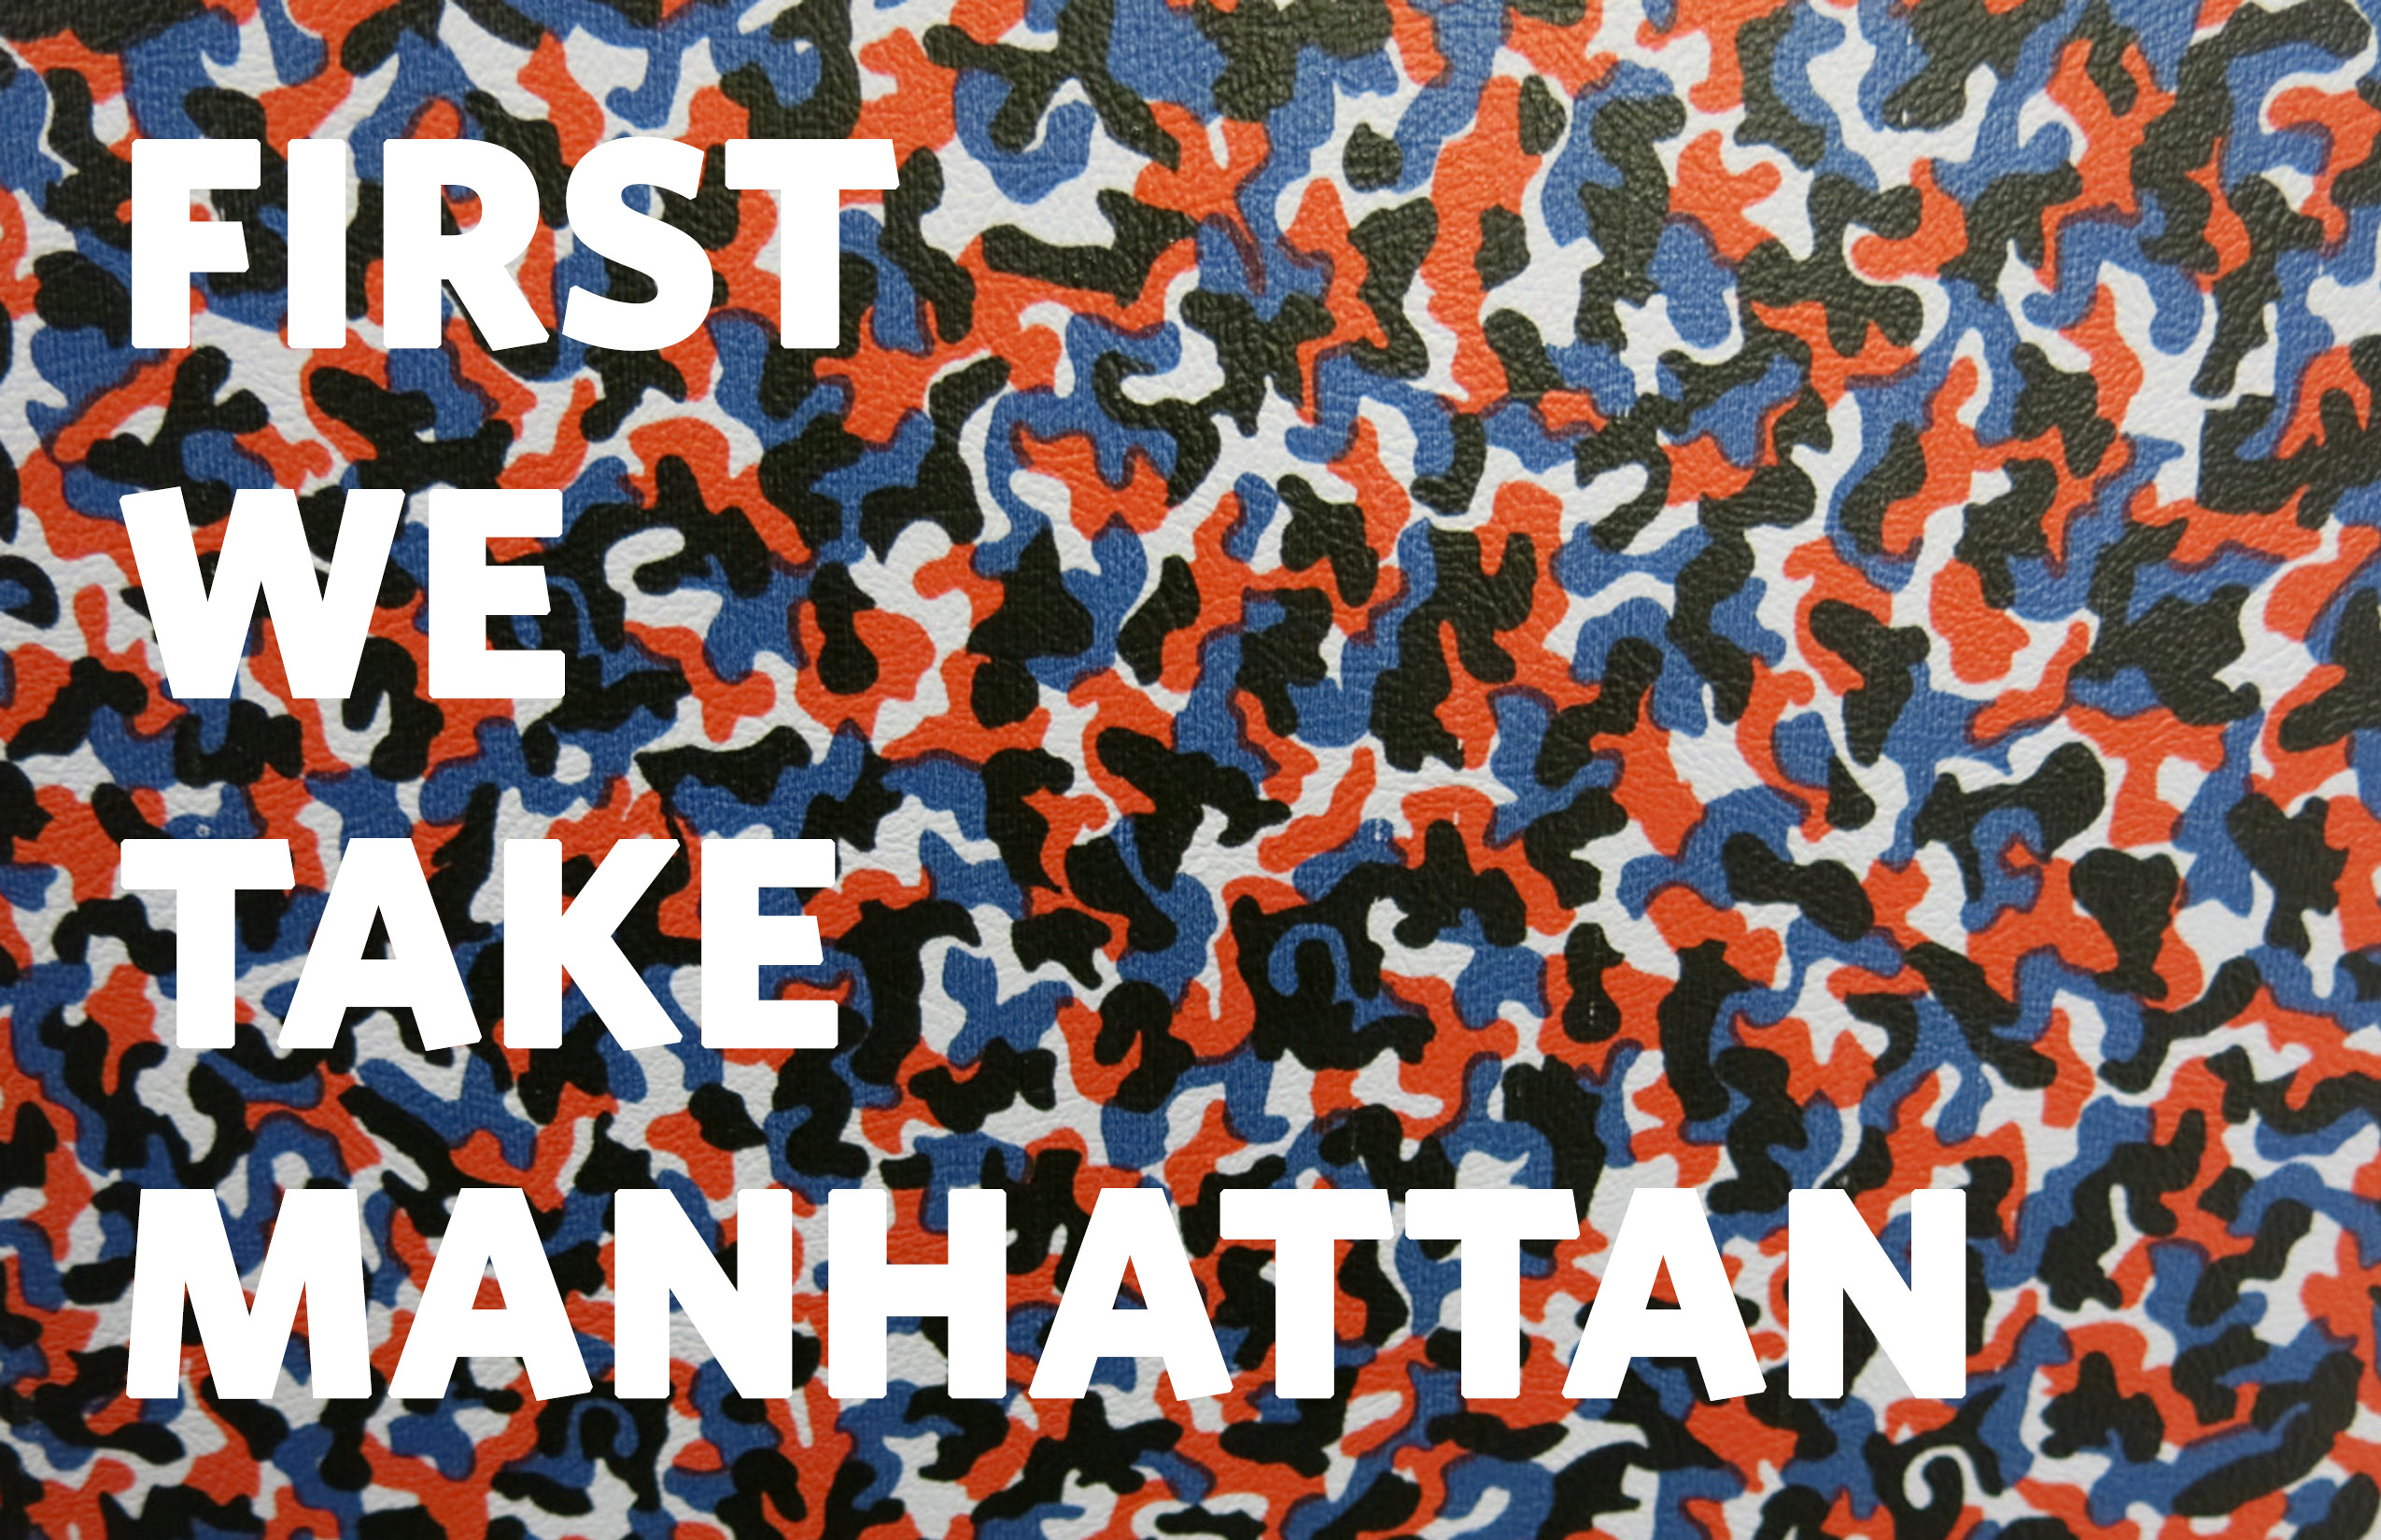

Ethan Cohen is pleased to announce: First We Take Manhattan, a group exhibition of artists selected by Isaac Aden as a continuation of his solo exhibition I Like America.
Reflecting the curatorial aspect of Aden’s practice and, concurrent with the exhibition I Like America, Aden organized First We Take Manhattan; is based on the internationalist agenda of Leonard Cohen. By conflate the predetermined roles of “artist” and “curator” Aden questions the limits of both. Rather than looking to overarching aesthetic or theoretical relationships, the selection process has been based on individual relationships between each work on a one to one basis, creating a thread, which makes connections both cognitive and sensorial.

Participating artists include:

Joseph Ayers
Jeff Conefry
Chajana denHarder
Nick Farhi
Derek Fordjour
Jeffrey Spencer Hargrave
Elektra KB
Andrew McNay
Irvin Morazan
Martin Roth
Gabriel J. Shuldiner
Wei Xiaoguang

The Opening Reception is May the 5th from 6 p.m. – 9p.m.
The exhibition will take place at Ethan Cohen Gallery from May 5th – June 20th, 2016.

Ethan Cohen Gallery: 251 W 19th St, New York, NY 10011
ecfa.com

