Artists Takeover the Old Beacon High School’s KuBe Art Center
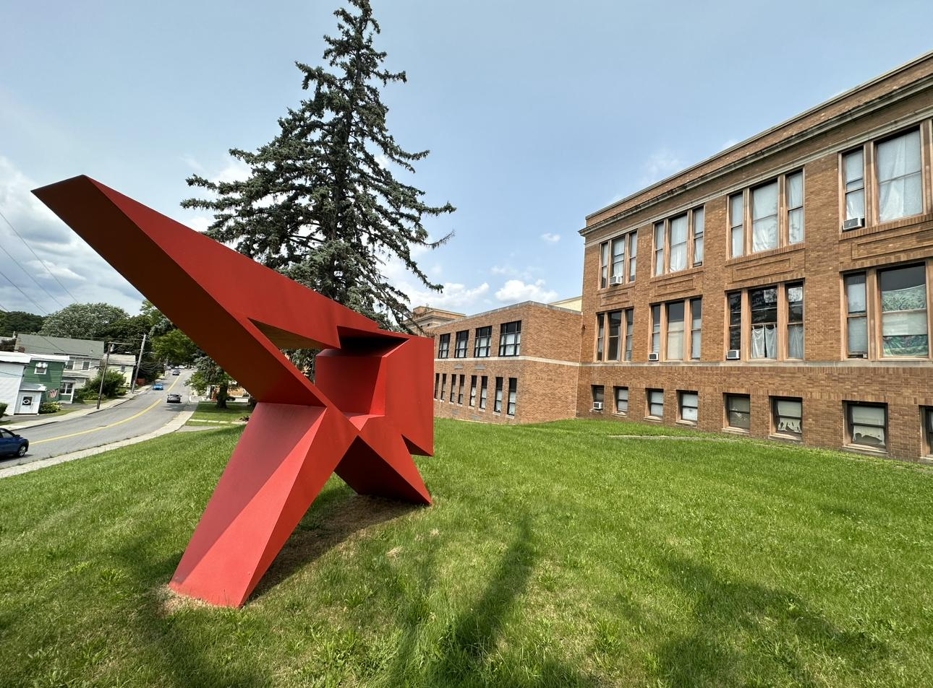
Artist: Alejandro Dron

BACK TO SCHOOL af
Imagine the high school experience you wished you’d had. No homework, no grades, no bullies, just art. Acclaimed curator Ethan Cohen and renowned pop artist Ron English have co-curated a Back To School art fest at the Kube Art Center. Explore subjects like “Irrational Experiments in Physics”, “Hip Hop 101”, “Sex Ed”, “Art History Reimagined,” Ron English’s take on the Warhol classic “Silver Fame Factory” and more! The exhibition runs from NOV 3, 2023 - MAY 18, 2024 starting with Homecoming and ending with a Prom.

“HOMECOMING” IMMERSIVE ART EXPERIENCE Friday, NOV. 3RD 7-10PM
Join us for an immersive High School experience. Don’t be late for orientation or you may get sent to “Cosmic Detention!” Listen for the bell, when Hall Monitors will show you to your next class. Watch out for Serious Comedy playing “High School Archetypes” in spontaneous improv throughout the building. Our evening culminates in the gym for “Homecoming” with a DJ Dance party and performances. Don’t miss your chance to experience high school like you never did before! RUBBER SOLES ONLY. Prizes for most imaginative sneakers. Tickets $45 / $50 at the door. Click here to get your tickets!

On Nov. 4 & 5 Back to School is also a destination spot for the Beacon Bonfire Music + Art Festival. Find out more at beaconbonfire.com

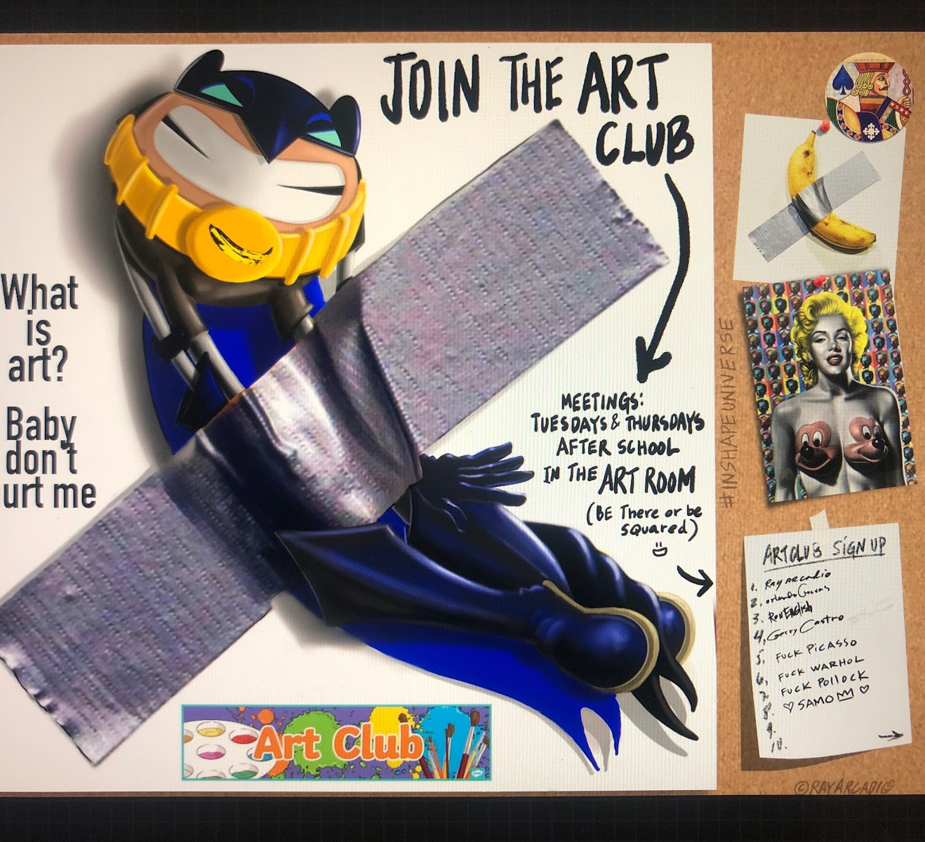
Artist: Ray Arcadio

Back to School participating artists:
Aboudia, Emil Alzamora, Chris Ams, John Aslanidis, Ray Arcadia, Gerardo Castro, Claudia Coca, Mina Cheon, Shi Chong, Orlando Cuevas, Michael D'Antuono, Thomas Deininger, Ron English, Jeffrey Spencer Hargrave, Eric Heist, Logan Hicks, Liu Xiao Hui, Frank Hyder, Sherry Kerlin, Mike Long, Goncalo Mabunda, Karen Michel, Donna Mikkelsen, Qi Ming, Catharsis Modombo, Anna Navasardian, Innocent Nkurnuziza, Yigal Ozeri, Michel Platnic, Russell Ritell, Kalene Rivers, Meghan Spiro, Kazumi Tanaka, Risa Tochigi, TC Weaver, Dan Weiss, Ai Wei Wei (documentary), Natalie White, Li Quan Wu, Liu Xiaodong, Gan Yu, Leon Zhan, Qi Zhilong

Exhibition: NOV 3, 2023 – MAY 18, 2024
HOMECOMING: Friday, NOV 3, 2023 from 7-10pm
OPENING Sat & Sun NOV 4-5, 2023 from 12-8pm

Tickets for Homecoming: click here
Find out more: backtoschoolaf.com

The KuBe Art Center
211 FISHKILL AVE BEACON, NY 10258
https://www.ecfa.com/kube

